MASS DIGITIZATION APP GUIDE

Corresponding to Mass Digitization App version: v.1.1.18
Version 3: 23rd of January 2024
System: MS Windows 10 Enterprise v. 10.0.19045
Written by: Chelsea Graham, Jan K. Legind and Pip Brewer
Location: N:\SCI-SNM-DigitalCollections\DaSSCo\Workflows and workstations\GUIDES\2 Masters

Contents
Initial Installation 2
Before You Start 4
Download and Install the Latest Version 4
To uninstall the previous version, complete the following steps: 5
To install the newest version, complete the following steps: 7
Opening and Logging into the App 11
General orientation 12
Entering Specimen Data into the App 14
Storage location 14
Preparation type 15
Type status 15
Notes 16
Multi specimen object 17
Taxonomic name 18
Barcode 20
Exporting and Saving Data at the End of Each Day 21
File name convention 23
Clearing the data from the database following export 24
Troubleshooting 25

Initial Installation

When installing the Mass Digitization App for the first time, start up the computer and monitor and log in with your personal credentials.

You are going to need to install the SQLite browser tool ‘DB Browser’ which can be had here:
https://sqlitebrowser.org/dl/

Please install this to a new folder on the C drive. On the folder itself, right click and select ‘properties’.
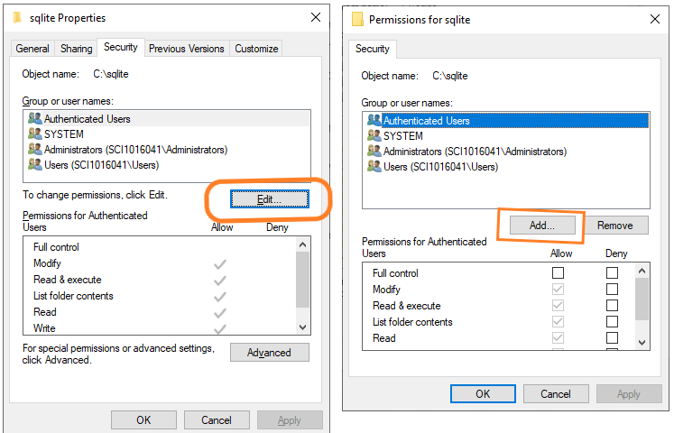

Under the Security tab you press the Edit button. Here you will need to add the shared account (SUA-SNM-DaSSCo01). Activate the ‘Add’ button and here you add the name ‘SUA-SNM-DaSSCo01’ in the text box, then press ‘Ok’. In the ‘Permissions’ window press ‘Apply’.
This will grant the shared account access to the SQLite browser tool. All this is due to the limited access that the shared account has.

Installing the Digi app:
Log out of your personal account and log in to the shared DaSSCo account:
Username: SUA-SNM-DaSSCo01
Password: zaq12Wsxcf=03

Check the Mass Digitizer GitHub page (https://github.com/NHMDenmark/Mass-Digitizer/releases).

The newest release will be toward the top of the page with “Latest” written next to it in green. In this case Version 1.1.18. We recommend relying on Chrome or Firefox web browsers for this step. Edge is not recommended.

We are currently only supporting the Windows operating system. The DaSSCo team are striving to include Mac support in the future.
.

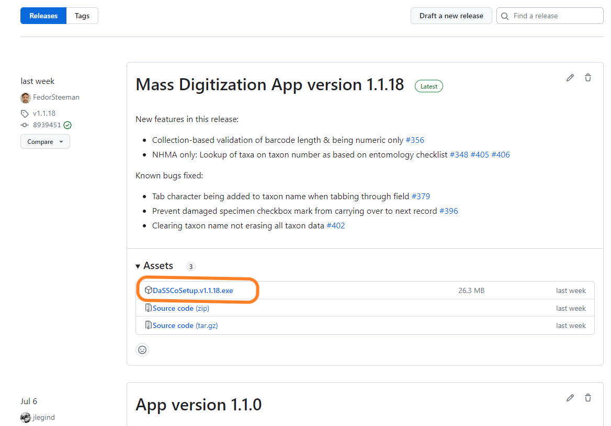

Please select the .exe file in the ‘Assets’ list. In this case “DaSSCoSetup.v.1.1.18.exe”

The download will commence and will likely go to your personal \downloads folder.

At this point you are given the option of discarding the download or keeping it. We want the latter option. Press the small arrow wedge to get access to the ‘Continue download’ option and click it.

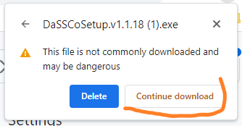

Move the setup exe file to the N drive: N:\SCI-SNM-DigitalCollections\DaSSCo\Digi App
At this point we are able to install the Digi app. When the app is installed from the N drive it becomes available to the shared account.

Before You Start

For daily use, start up the computer and monitor and log in with the DaSSCo credentials for the shared account.
Username: SUA-SNM-DaSSCo01
Password: zaq12Wsxcf=03

Make sure there is an internet connection at this point. Internet access is required in order to log in. After logging in, an internet connection is no longer necessary until the process of exporting data to the server.

Ensure the barcode reader is connected to the computer via USB cable.

Arrange the workspace to your comfort.

Check the Mass Digitizer GitHub page (https://github.com/NHMDenmark/Mass-Digitizer/releases) to see if there has been a new release.

If there is a newer version, follow the instructions to download and install it.

Download and Install the Latest Version

Please make sure that you back up the embedded SQLite3 database file PRIOR to installing the new release. There is a culture of uninstalling the App before installing a new release. This is in many cases a good idea, however we must back up the existing database before uninstalling or installing (on top of) in the name of good data governance.

You do not need to re-install the DB Browser, only the Digi App.

Before you begin the actual installation, you must log in to the workstation with your personal log in. This is to make the installation available to the shared account. Please see the Installation section on page 2 for instruction on this.

Before you download and install a new version of the App, make sure that you have saved all data collected on the app (see Exporting and Saving Data at the End of Each Day). This is important – otherwise you will lose any un-exported work!

When you need to install a new version, please make sure you have uninstalled the previous version of the app that is on your computer as outlined in the next section of the document.

Lastly be aware that the installer creates a DaSSCo folder structure in the Document directory which contains the SQLite database as well as a logs folder. These are necessary for the app to run!

To uninstall the previous version, complete the following steps:

Go to the start menu and click on Settings (the cog symbol)

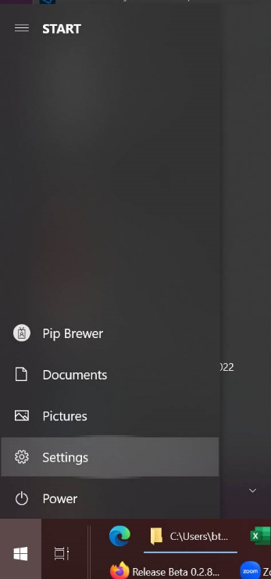

This will bring up the Windows Settings menu. Select Apps.

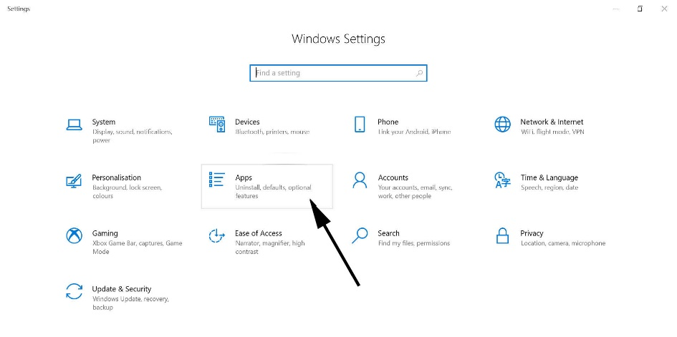

Scroll through the list of Apps until you see the DaSSCo Mass Digitizer app listed

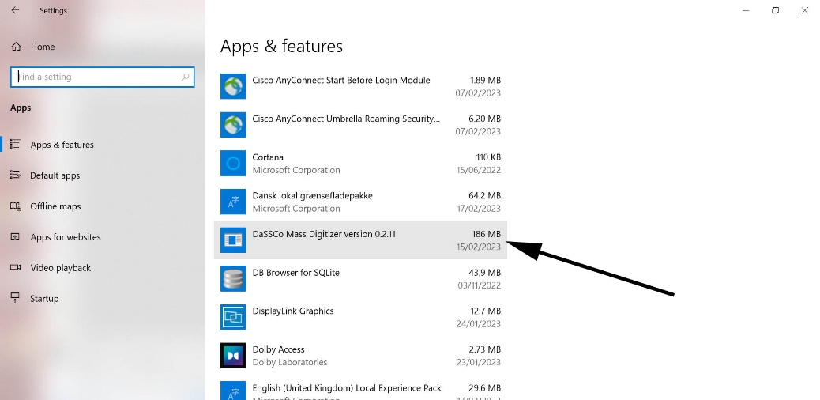

Click on it and select Uninstall.

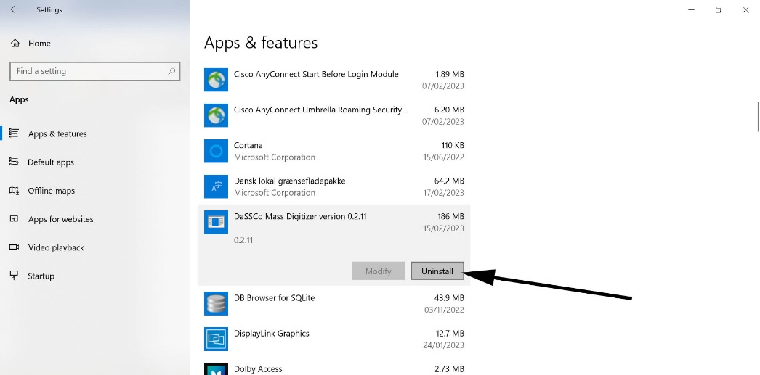

You may need get one or more pop up boxes. Continue to uninstall.

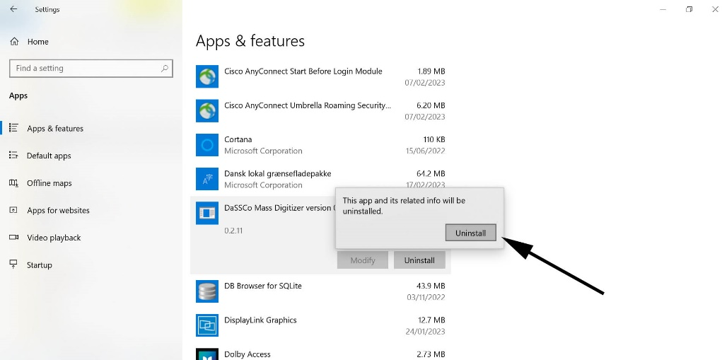

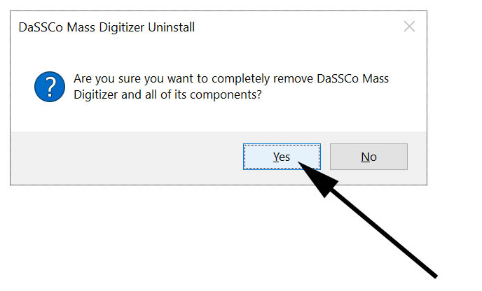

After this process, you will receive a notification that the App has been removed.
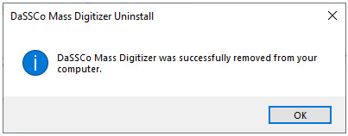

In addition to this, please close and save any data from DB Browser for SQLite, or any database browser, that you have open as this can interfere with the installation process.

To install the newest version, complete the following steps:

Log in to the shared account SUA-SNM-DaSSCo01.

Find the newest release on the Github page: https://github.com/NHMDenmark/Mass-Digitizer/releases

Select the newest release and it will now download onto your computer.

You must move the installation file to the N drive in the N:\SCI-SNM-DigitalCollections\DaSSCo\Digi App folder. From here on you follow the instructions in Initial Installation .

Once you have clicked (or double clicked) to install the app, the following window might appear.

Now, in the window select More info

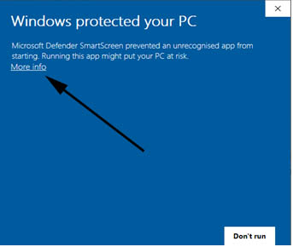

Then select ‘Run anyway’.

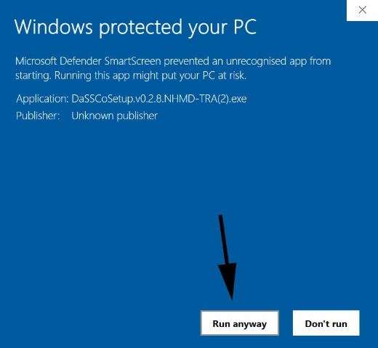

A window will appear and the location to be installed will be automatically selected. Do not change this installation location or the app will not work.

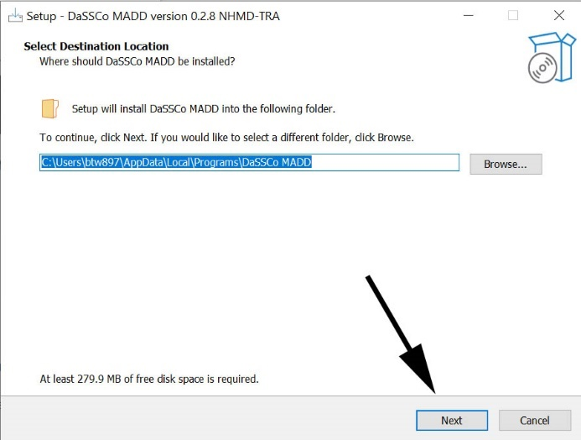

Select next. If a prompt about ‘This folder: … already exists’ simply press ‘Yes’.

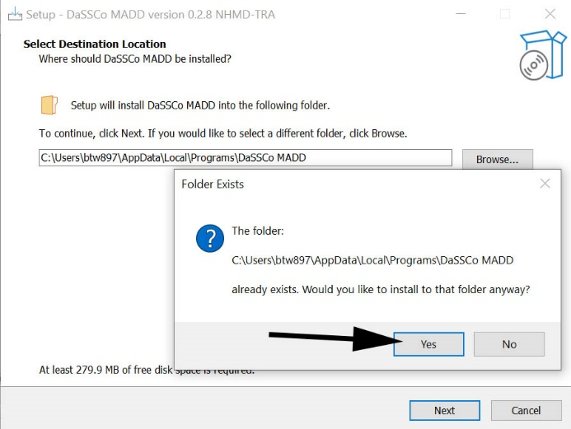

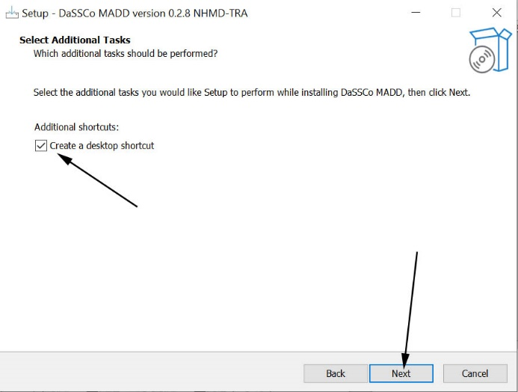

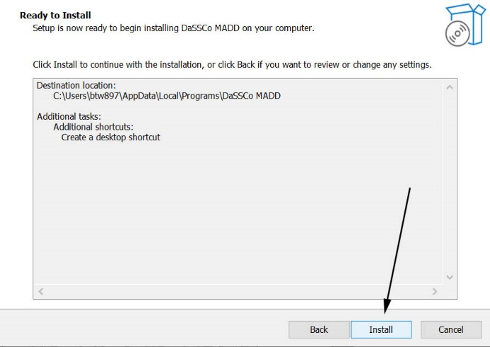

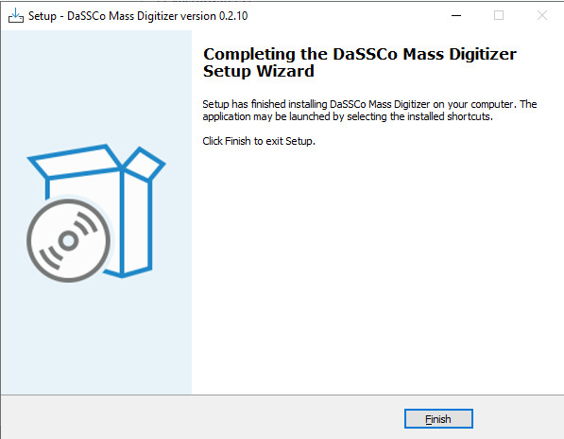

Installation is complete at this point.

Opening and Logging into the App

Open the DaSSCo Mass Digitizer program on the desktop by double clicking the icon:

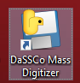

A log in window will open where you can log in by selecting the relevant institution from the dropdown menu.

Enter your Specify username and password.

Select the appropriate collection to log in to.

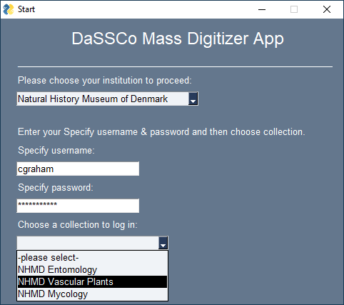

A window entitled ‘DaSSCo Mass Digitizer App’ will open:

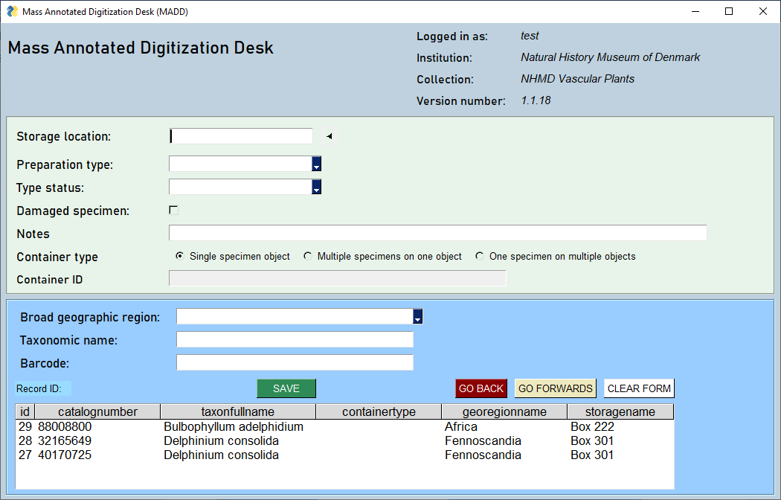

This is the window you will use for digitization.

General orientation

The grey top section contains details of the session, such as who is logged in and to what institution and collection (the information entered into the previous log in screen). This information will be associated with each specimen. It also shows the App version being used.

The green area captures information that is unlikely to change often from specimen to specimen. It can be captured at the beginning of a group of specimens (e.g., a folder or tray).

The blue area is where most activity takes place and is separated in order to draw your eye and focus to this part of the window, whilst digitizing.

Please notice the indicator arrow that points to the active field as you add content to the form.

At the bottom of the window is a white table. Once you start digitizing, you will be able to see the last 3 records you have digitized here for reference.

All of the fields in this window – except barcode and Damaged specimen - are designed to be “Sticky”. That is, they retain the information you have entered so that you do not need to enter it again for each specimen. This is to enable rapid digitization once you have filled out the data common to that group of specimens (i.e., that data on the front of folders or drawers or trays). After this, you simply need to scan the barcode and save the record before moving onto to subsequent specimens.

How to Navigate the Fields in the App

There are different types of fields used in this App – such as free text fields, list boxes etc.

As a result of the software used to develop the app, how you navigate these fields, depends on the type of field it is.

This takes a little bit of getting used to.

Navigation of the fields is intended to be used almost exclusively with a keyboard, to minimize switching between the mouse and the keyboard.

- To navigate down through fields, use the tab button

- To navigate in reverse (up through the fields), use shift+tab

- To select a check box or activate a radio button, press the space bar

- To select from a drop-down list, use arrow keys and press enter to select the value you want

- To use the buttons at the Go-back, Go-forward, and the ‘Clear-form’ buttons at the bottom of the app, you need to click those using the mouse.

- Scanning a barcode triggers the ‘Save’ operation, so make sure the form is complete before a scan.

  - Go-Back and Go-Forwards buttons

These buttons are useful for stepping back to an earlier record to update it. Recognizing that there will be mistakes made along the way, we have implemented the option of travelling back in time to fix your mistakes or oversights. For instance: This would be a good way to clear multispecimen identifiers that were left hanging (see further below for more details on multispecimen objects).

Navigating to previous records using these buttons, will commit any changes you make to the form as an update when you save the particular record that you landed on.
There are two ways to submit a new record from the place that you navigated to:
- Press the Clear-form button and type in the new record
- Go-forward until you come to the most recent record and press Go-forward once again. This clears the Record ID label but retains the sticky fields for that most recent record. From here a new barcode can be scanned and the new record submitted.

Clear Form
This will clear the form of all input including sticky fields. You can enter specimen data again and save it as a new record.

Entering Specimen Data into the App

Most of the data entered into the App will be common to more than one specimen in a group and can be found on the front of the folder (in the case of herbarium sheets) or drawer or tray (such as for entomology collections). The App exists to capture this and associate it with individual barcodes (which will form part of the catalogue number) that are assigned to specimens within that group (folder, tray, drawer etc.). The information will be used to create individual records in Specify at a later stage. We can then attach other media (such as images) and more granular information (such as collector name) to these records subsequently.

Storage location

The specimen storage locations from Specify have been loaded into the App and you can select them by using this field. These locations can be specific (such as to box or drawer level), or they can be at the level of ‘building/site’.

The default for this field is set to None. If it has been agreed with the collection manager and curator beforehand that storage location will not be entered for the specimens, you can simply ignore this field.

If you wish to enter the storage location, simply ensure the cursor is inside the field (there should be an arrow to the right of the field to show where the focus is), then start typing. After the first 3 letters are entered, the App will start searching for the locations which have been loaded from Specify which match your search and result in a pop-up box with suggestions. If you cannot see the location you need, you can keep typing until it appears.

Using the example illustrated below, if you start typing “Box” while logged in under NHMD Vascular Plants, the pop-up box will appear and result in some options. Use the arrow keys to get to the one you want, and press enter.

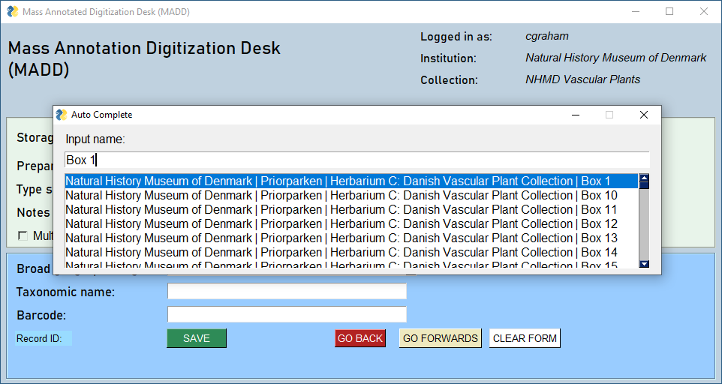

The selected suggestion will populate in the ‘Storage location’ field immediately.
The full storage location (from Specify) will be visible to the right of the field.

Preparation type

In the ‘Preparation type’ field, select the appropriate preparation. This field contains predefined data and is based on options in Specify. It is not currently loaded with all the options from Specify, but each preparation type is being added as a workflow which is developed for DaSSCo.

If the workflow is pinned insects, then “Pinned” should be selected. If it is herbarium sheets, then “sheet” should be selected.

Type status

In some cases, you may come across a type specimen in the collection. How you deal with this will depend on the collection, institution, and workflow in question. Information and training will be provided separately on how to recognize and deal with type specimens.

For the NHMD Vascular Plant collection, all type specimens will be skipped and will not be dealt with as part of the DaSSCo digitization, as they have already been digitized. Simply move onto the next specimen. For AAU herbarium, types will be digitized. For NHMD entomology, you are unlikely to encounter types as they are kept separately.

For the vast majority of specimens, simply select “None” as the type status.

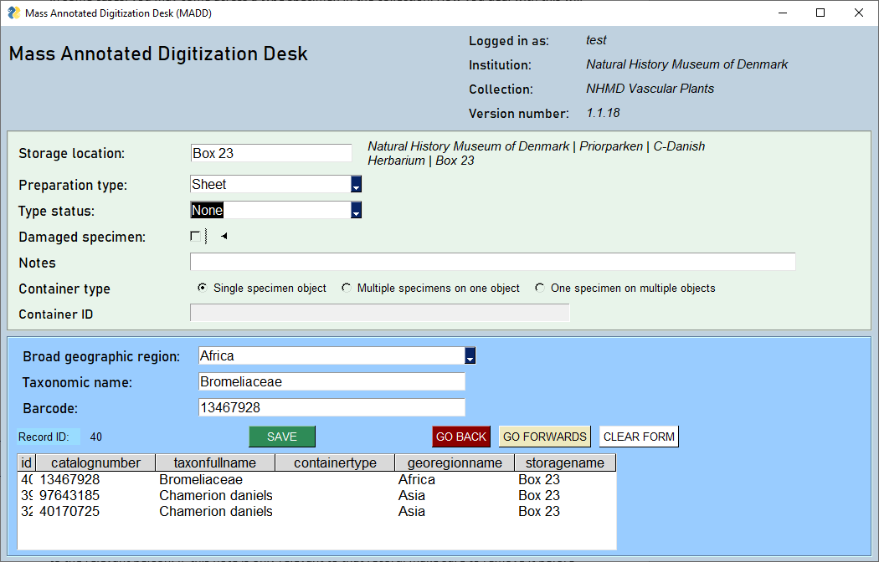

Notes

The Notes field is provided as somewhere to add comments, if necessary. Notes should be kept to a minimum and only included if absolutely necessary.

Example: If you have concerns about legibility of the specimen label and would like a curator or collection manager to look at it, then adding the issue to notes is legitimate.
If the note is relevant only to that record, make sure to remove it before proceeding or else it will be applied to the next record as well.

Do not write commas in the Notes Field, as it interferes with the formatting of the records later down the line.

Multi specimen object

The object type can be one of three kinds:

- Single Specimen Object (SSO) is one specimen on one container. This is the default type.
- Multi Specimen on One object (MSO) is one container (sheet, pin, jar, etc.) with multiple specimens
- One specimen on multiple objects (MOS) is one specimen across multiple containers

If you activate one of the two ‘multi’ radio buttons, the text field will be populated with a ‘Container ID’; a random identifier (one number among several quintillion) which is assigned to the multi specimen object. This ID associates disparate barcodes.
It is vital that this ID is retained until all the specimens which are physically associated together are digitized.
In the case of herbaria sheets where the specimens on the sheet have individual barcodes, this would be after all the barcodes have been entered and saved. If there is only one barcode as is the case for pinned insects, this would be after that barcode has been saved.
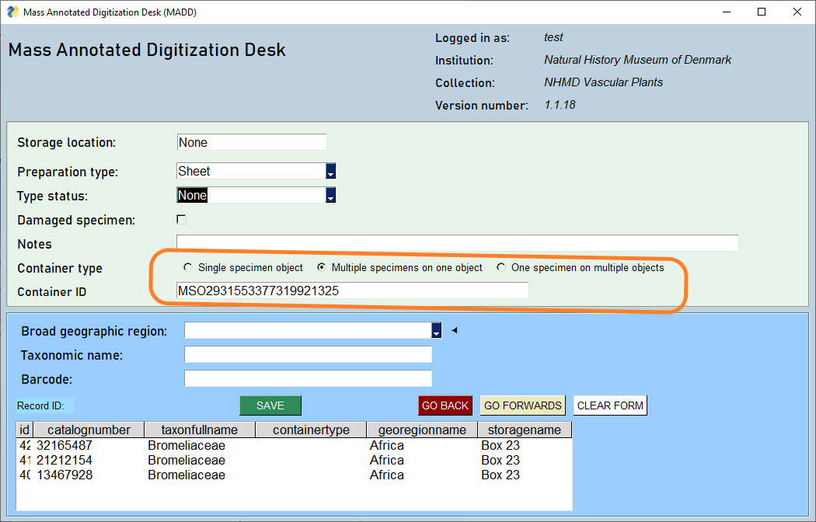
After this point, activate the Single Specimen Object radio button again.

If you move directly onto another specimen, which is also a MSO or MOS, activate the appropriate multi radio button again and a new ID will be generated.
Please make sure you tick the button again to get a new number, otherwise all the specimens will be associated under one ID when the records are imported into Specify.
Likewise, we implore you to deactivate the multi radio button when the MSO or MOS has been scanned, otherwise several unrelated, single specimens will be associated.

The default should always be the Single Specimen Object radio button.

If you do forget to activate the SSO button, please use the ‘Go Back’ and ‘Go Forwards’ buttons to correct the records. Move back to the first record, that should have been marked as an SSO, activate the SSO button and hit ‘Save’. Press the ‘Go Forwards’ button, correct the next record, hit ‘Save’ and so on until you correct the most recent record. Hit ‘Go Forwards’ one more time to create a new record, ready for the next scan.

Broad geographic region

The geographical region pick list is specific to the individual collection and has been added to Specify and pre-loaded into the App. If none is given, there is an option to select “None”. These regions will likely vary with each collection.
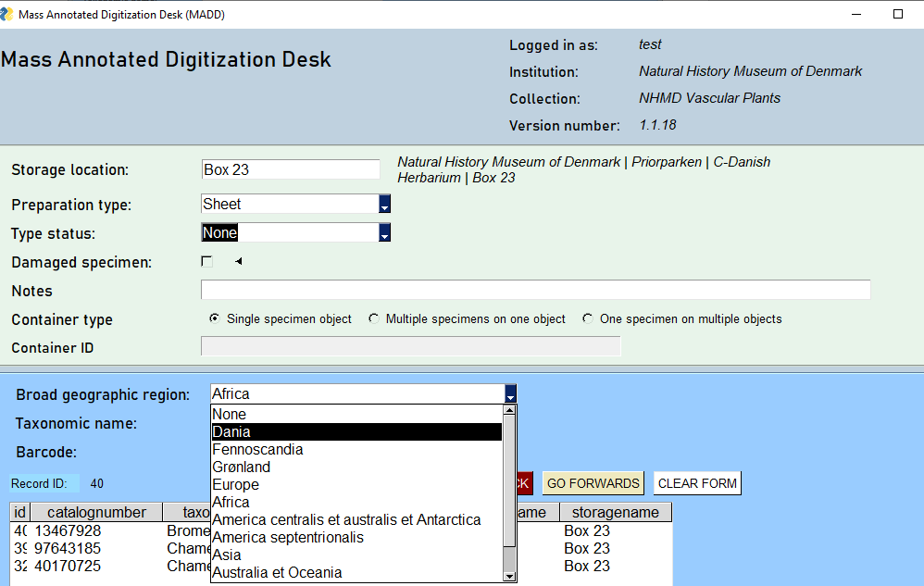

Taxonomic name

In the ‘Taxonomic name’ field, begin typing the name present on the front of the folder, exactly as written. A window entitled ‘Auto Complete’ will open after three letters. Continue typing the taxonomic name until the correct option is available in the list box as seen below.
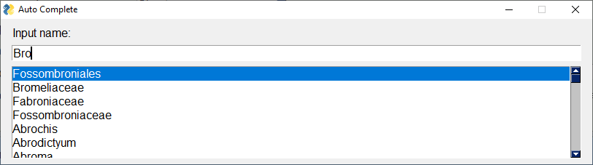

The auto-suggest function matches anywhere in the name. This means that it will search for those three letters inside the name as well as at the beginning of the name. To select the correct name, either keep typing until it is resolved or use the arrow keys and enter button to select the name.
The name will now populate the “Taxonomic name” field box.
We urge you to be very careful about typing in taxonomic names as they are very specific.
Most specimens to be digitized are determined at least to the rank of Genus.
- The rank Genus gets one name, like: Giraffa or Betula.

If a specimen is determined to the species level it gets two names:
- The rank species places the species name or specific epithet after the genus name, like: Phataginus tetradactyla or Broussonetia papyrifera

The specimen can be even more specifically determined, either on the genus level or species level:
- The rank subgenus places the subgenus name in parenthesis after the genus name, like: Leptusa (Halmaeusa) in zoology and uses a connecting term, subg. between the genus and subgenus name, like: Acacia subg. Phyllodineae in botany.
- Rank subspecies places the subspecies name after species name, like: Panthera pardus pardus in zoology and uses a connecting term, subsp. between the specific epithet and the infraspecific epithet, like: Calystegia sepium subsp. americana for botany.

In botany there are four ranks below subspecies:
- variety, var.
- subvariety, subvar.
- forma, f.
- subforma, subf.
These are all indicated by using their connecting terms (var., subvar., f., subf.) between the specific epithet and the infraspecific epithet: Acanthocalycium klimpelianum var. macranthum, Astrophytum myriostigma subvar. glabrum etc.

A botanical name has a maximum of four parts: Genus, specific epithet, connecting term, infraspecific epithet, ‘cultivar name’. The connecting term is not part of the name, only an indicator.
Note that a specimen may be described with multiple connecting terms and infraspecific epithets, but the formal name will still only consist of four parts.

Hybrid specimens are indicated by the multiplication sign “×”. When typing in the app use the letter “x”.

In botany, author names, sometimes abbreviated, are part of the scientific name. Most important to note is that both botany and zoology uses the abbreviation “L.” and “Linn.” to indicate Linnaeus as the author.
“L.fil.” and “L.f.” indicates Linnaeus the Younger, Linnaeus’ son and not Linnaeus himself.

If, after typing the entire taxonomic name exactly as written on the front of the container, there are no matches, check the label for available information on the name.

If author name and year is written on the container add the information in the following manner:
Taxon name_Author, year
For example: Ancylis paludana_Barrett, 1871

Be sure not to add spaces around the underscore.

Press the ‘Enter’ button on the keyboard. In the new field titled ‘Input family name’, begin to type the family name. If the name is family rank or higher then no input is needed. Family name is important because it helps us assign the name into the correct place in the taxonomic tree in Specify.

If the family name does not autocomplete that means it is not in the taxonomy. Please type it in verbatim and press OK (tab and press Space bar).

Taxonomic names added in this way will be flagged in Specify to be reviewed by a collection manager or curator.

Barcode

At this stage, you will have entered all of the data common to that group of specimens (such as taxon, broad geographic region etc.). You can now proceed with rapid digitization, by scanning in the barcodes of individual specimens into the App. A completed scan triggers the Save function automatically.

All barcodes are fixed to a certain number of digits depending on the collection. If you enter a number which does not conform an error message will appear, and you will need to rescan the barcode.

After a completed scan the barcode is assigned to the specimen.

If working with herbarium sheets, barcodes should be assigned to the upper left corner, or as close to it as possible.

If working on pinned insects, the barcode should be placed on the imaging stage with the specimen and its labels and imaged. Afterwards the labels should be re-pinned with the barcode being lowest on the pin.

Exporting and Saving Data at the End of Each Day

At this point we would want the day’s data harvest to be transferred to a location where the data is safe and can be accessed by the DaSSCo team.

Please start up your “DB Browser for SQLite” database editor. This should already be installed on your machine. If not, please refer to installation instructions above.

Open the database, which is located in the ‘Documents’ directory / ‘DaSSCo’ directory – the file name is “db.sqlite3”.

Under the ‘Browse Data’ tab select the table ‘specimen’.

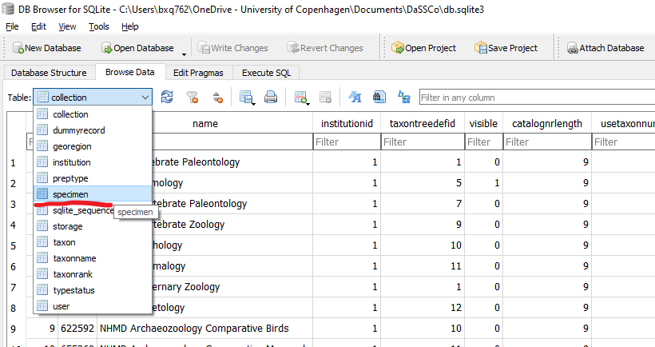

This would be a good place to do a final check to see if the table looks sound. No deep dive into the data is necessary, merely a quick glance.

Now select “file” / “export” ↴

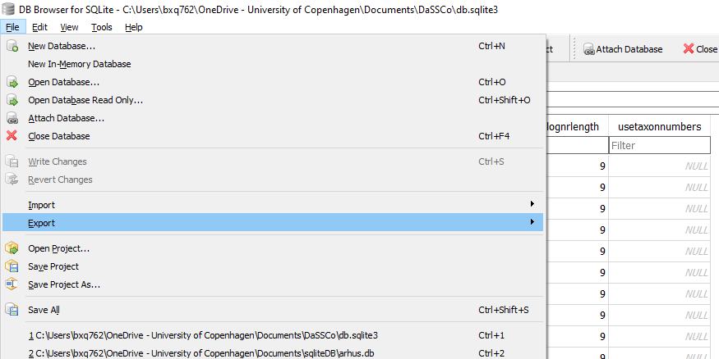

You need to export the data as a csv file. The only table you need to export is the specimen table (see image below).

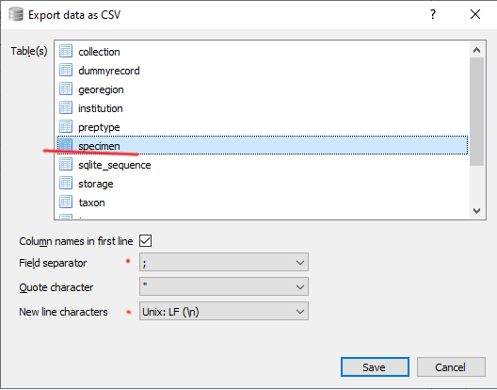

Please make sure that the “column names in first line” tick box is checked.

The field separator should be semi colon and not comma because the comma character is such a ubiquitous symbol that any occurrence of this risks breaking the table structure.

Also select the UNIX style new line character which is a single line feed (\n).

Press Save.

The data needs to be transferred to the following directory:

N:\SCI-SNM-DigitalCollections\DaSSCo\Digi App\Data\0.For checking

It is useful to have a shortcut to the N:/ drive is accessible on the desktop.

If you do not have access to this directory, please save the file locally (e.g., C:\Users\Documents\DaSSCo\DigiApp\Data\ExportedDataFiles if you are working on the herbarium computer) and send it via email to Pip Brewer.

File name convention

The file naming convention is:

[Collection name], [_yyyyMMdd_HH_MM], [_initials of the digitizer], [ _original]

Example:
NHMD_Herba_20230621_14_05_MG_original.csv
NHMD_PinnedInsects_20230621_14_05_MG_original.csv

Final check

We urge you to do a final comparison between the saved CSV file which can be viewed in a spreadsheet application, and the specimen table which you can see in the “DB Browser for SQLite” tool.

In order to view the data in the csv file in Excel. Open it up and select the column with the data in it.

Navigate to the Data tab on the ribbon. Click on “Text to columns”.

Choose delimited and then “Next”. “Semicolon” should be the only delimiter selected.

Press “Next” again and then “Finish”.

You should now be able to see the data in columns. Compare this with the data in the DB Browser for SQLite table.

If everything looks fine, then just shut down the spreadsheet. I should be transferred as described above.

The digitization content will be transferred to Specify at regular intervals.

After you are absolutely sure that all of the data has been saved successfully as a csv file in the above directory, you can clear the SQL specimen database table (ONLY the specimen table).

Clearing the data from the database following export

The following steps should be performed after you have exported the data and carefully checked that it has been fully saved in the csv file.

In DB Browser for SQLite, click the ‘Browse Data’ tab

From the drop down menu (titled “Table”), select “specimen”

In the upper left corner left of the table header click that empty space (Red dot - see screen shot)

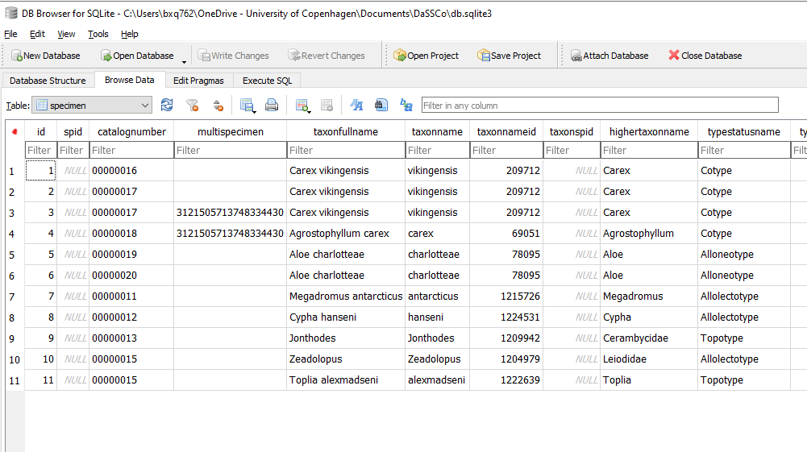

This action will select every record in the specimen table.

Now press the ‘delete’ key on the keyboard. The records will disappear.

To persist this deletion, you must press the ‘Write Changes’ button in the upper bar (framed in orange).

Troubleshooting

If you have any questions, comments or suggestions on the App, please post these on the Slack “NHMDDigiColl” account (dassco-digitization-app channel) or “All DaSSCo Digitization” account (general channel).

There are still a few bugs with this App which we are working on to resolve. However, it is fine to digitize using this version. We will continue to work on the App, not only to fix the bugs but also to provide new features to make it easier to use. We welcome feedback. We are however limited in the resources we can spend on developing the app and so it is necessary to prioritize requests.

Navigation issues. Please be aware that you will need to clear the form or use the Go-forward button all the way to the first record plus one step further to prepare the app for a new record. Many times, the already entered data applies to the next specimen except for the barcode. It is nice to have the option of reusing data where appropriate.

The Clear-form button is for removing form data for when the upcoming specimen container has different data.

Unwanted fields. In some cases, there may be fields in the App which are not needed in a particular context. In future iterations of the App, we hope to be able to make it possible to customize the fields that you can view. However, in order to release a functional App to start testing and digitizing it was necessary to prioritize what is developed first. In this case, the App will still function with these fields present, and they can be ignored and so this has not been a priority feature for the first version of the App.

Technical note: The ID is a hash value of the timestamp which goes down to microseconds. In itself this is a good unique value. In the very unlikely case that two digitizers were to mint an ID at the exact same time down to microsecond, there is going to be a collision which is why a random number is concatenated to this hash value.

